**COMSATS University Islamabad, Abbottabad Campus**

**Department of Computer Science**

**Project Proposal**

**Blood Donation Management System**

**CSC392 Object Oriented Software Engineering**

Submitted on: <10-1-23>

Group Members:

Waleed Khan (SP21-BSE-026)

Ahmed Bajwa (FA20-BSE-169)

Mattiallah Safi (SP21-BSE-030)

Tayyab Rafique(SP21-BSE-024)

Muhammad Ali Raza(FA20-BSE-048)

Muzamil shirzad(sp21-bse-005)

Table of Contents

**CHAPTER 1 PROJECT PROPOSAL** 5

**Introduction** 5

**Vision and Business Case** 5

**Vision** 5

**the business case** 6

**Use-Case Model** 6

**Supplementary Specification** 7

**Glossary** 7

**Risk List & Risk Management Plan** 7

**CHAPTER 2 USE CASES** 8

**Use Case Diagram** 8

**Use Cases Distribution** 9

**Brief Level Use Cases** 9

**Waleed Khan (SP21-BSE-026)** 9

**Use Case 2: Donate Blood** 10

**Fully Dressed Use Cases** 10

**Waleed Khan (SP21-BSE-026)** 10

**Use Case UC1: Check donors list** 10

**Use Case UC2: Donate Blood** 13

**Chapter 3** 36

**Domain model** 36

**Chapter 4** 37

**SSD** 37

**Waleed khan (SP21-BSE-026)** 37

**Waleed khan (SP21-BSE-026)** 38

**Forward Engineering** 38

**Backward Engineering** 39

**Chapter 5** 43

**Operation Contracts** 43

**Waleed Khan (SP21-BSE-026)** 43

**Chapter 6** 48

**Package Diagram** 48

**Forward Engineering** 48

**Reverse Engineering:** 49

**Chapter 7** 50

**Interaction Diagram** 50

**Communication diagram** 51

**Chapter 8** 53

**Class Diagram** 53

**Waleed Khan (SP21-BSE-026)** 53

**Chapter 9** 55

**Test Cases** 55

**Waleed Khan (SP21-BSE-026)** 55

**Waleed Khan (SP21-BSE-026)** 57

# **CHAPTER 1 PROJECT PROPOSAL**

## **Introduction**

Blood donation system is a system where different categories of people donate their blood To the needy person across the country. People will store their information on the system i.e. their mobile number, NIC number, blood type, medical history etc. and the system then scan for the appropriate person who fits the description and match the pair. The donor will be informed right after the blood has been donated. Also some verification will also be made on the person who needs blood incase of any misinformation provided by him to the system. The donor can set his data public or private. Incase he doesn’t want to be traced. Blood donation bank will also play an important role as all the blood will be stored in the bank.in case a person requires more blood then he will pay for the blood, the poor and needy person will be given free blood. In the end if the person had successfully recovered from an illness due to the blood donated to him then he can also give something (present)to the donor as a good gesture.

## **Vision and Business Case**

## **Vision**

The vision is To become the leading world class blood system in the innovation of new services, technology and research that positively impacts blood product safety and availability and enhances the live of our team members. The system makes the overall project management much easier and flexible.

***executive summary***

It is a blood donation management system which will serve human by automating the process of blood donation .It will consist of a website which will be connect to all blood donation center and a database to add blood, record blood donation history ,doner medical back ground as well as the patent record who are in need of blood in emergency cases or on regular bases(thalassemia patent) in addition to this there will be a reward system which will provide rewards for the doners

***the high-level goals and constraints***

|  |  |  |  |
| --- | --- | --- | --- |
| High-level Goals | Priority | Problems and Concerns | Current Solutions |
| Fast, user friendly, blood management system | High | Website link down in case of high use.  Lack of up to date accurate information from database and other blood donation centers due to non synchronization |  |

## **the business case**

* *Donor Management: Doner will donate blood which will be managed by blood donation management system*
* *Seeker Management: Seeker will request blood donation management system for a particular blood type which will be required by them*
* *Donation Management: this module will contain the list of donors along with the blood type that is donated by them.*
* *Stock Management: This module will deal with the all types of blood which are currently store in the repository of blood donation management*
* *Receiver List Management: this module deal with the all the person list that has successfully received the blood that was required by them.*
* *Reward Management: In this module it will manage the reward system of blood donation management.*

## **Use-Case Model**

* Login: it will perform the local login function
* Registration: it will perform the local login function
* Manage System: it will manage the whole blood donation management system
* Donate Blood: Donate blood will enable the donor to donate blood
* Conduct Test: Conduct test function is a function through which donor will be able to test his blood before donation
* Request Blood: Request blood is a functionality of BDMS where a certain type of blood will be requested
* Accept Request : BDMS have a functionally of accepting blood request from a particular seeker
* Check Emergency: BDMS will gather circumstances through this feature under which blood is requested
* Check Donor List: This feature will enable BDMS to check donor list incase of emergency situation
* Check Stock: Check stock feature will enable BDMS to check the stock of blood bank
* Adding Receiver in list: This feature will be used to maintain the list of all the seeker that have received the blood in the database of BDMS
* Managing reward: this feature will manage the information of rewards that have been received by the donor

## **Supplementary Specification**

* Free blood must be given to the needy and poor person
* Donor and the seeker must be in range
* Text should be bold and clear
* Text must be visible from 1 meter.
* Result should be displayed within 30 seconds 90% of the time
* Text should be bold and clear

## **Glossary**

* *Blood Donation Management System BDMS*

## **Risk List & Risk Management Plan**

* **Getting Doner and seeker in range**: doner and seeker will be linked by identifying their current location
* **Getting the right blood type to the right person:**  person will be identified through some verification process
* **Getting authentic blood info:** blood information will be verified by conduction blood test
* **Verifying the donor information:** donor information will be identified by the documents submitted by them
* **Management of blood bank stock :** blood bank stock should be kept up to date and manage by a data base system
* **Management of rewards:** rewards should be managed by process so that the right donor gets the reward

# **CHAPTER 2 USE CASES**

## **Use Case Diagram**

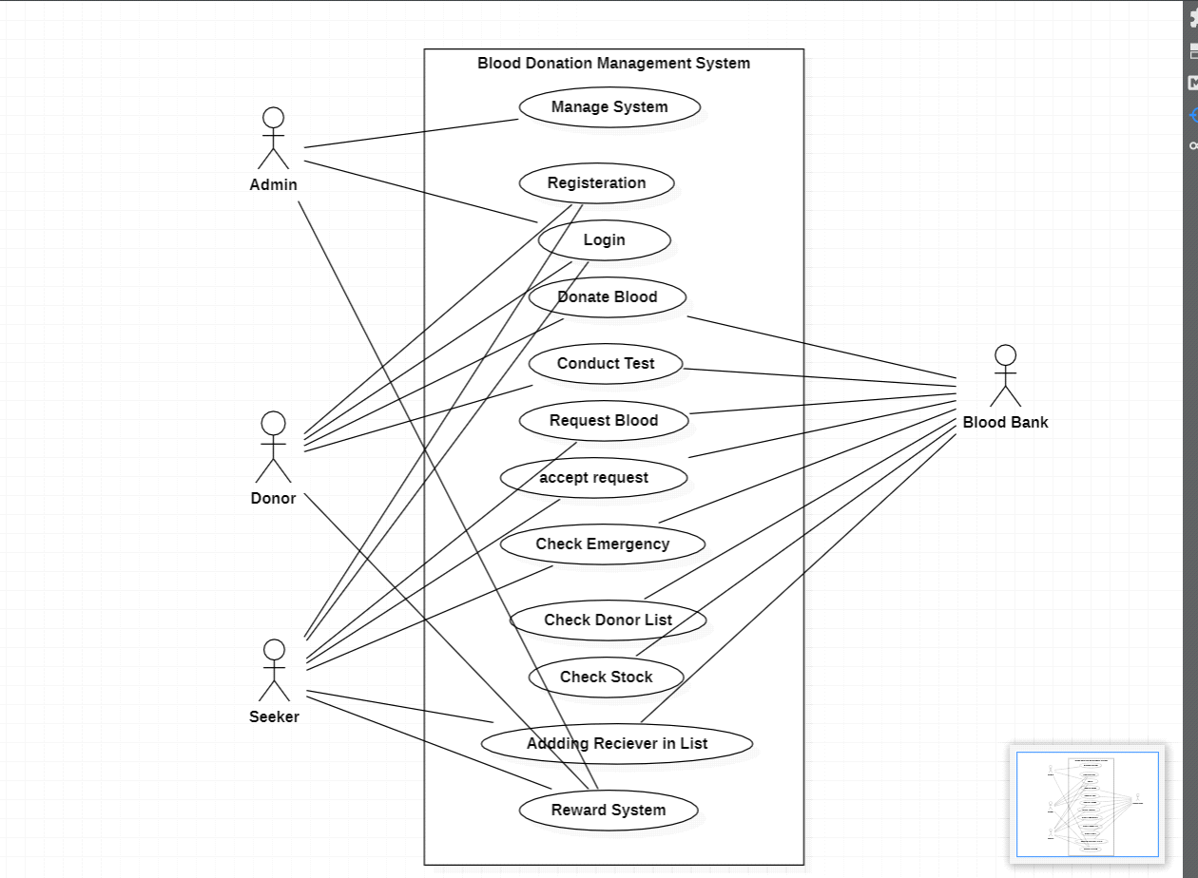

## **Use Cases Distribution**

|  |  |  |
| --- | --- | --- |
| S#. | Group Member | Assigned Use Cases |
| 1 | <Waleed Khan>  <SP21-BSE-026> | UC 1 :Check Donor List  UC 2: Donate Blood |
| 2 | <Muhammad Ali Raza>  <FA20-BSE-048> | UC 4: Sign Up |
| 3 | <Ahmed Bajwa>  <FA20-BSE-169> | UC 12:Reward System  UC 8 :Emergency |
| … | … | … |

## **Brief Level Use Cases**

### **Waleed Khan (SP21-BSE-026)**

#### **Use Case 1: Check Donor list**

The seeker ask for a particular blood type. Then the BDMS search for that particular blood. the blood bank if it is not available then it will search in the other blood banks at the End the Admin will search in the Data base of the DBMS if no blood is found in the blood bank. The admin will then search for the same blood group type donor. the blood group type donor is found and he is also eligible to donate blood. The donor will be requested to donate blood . the donor will willingly donate blood at the near blood bank which will further be delivered to the seeker

### **Use Case 2: Donate Blood**

Registered donor can willingly donate blood in the blood bank whenever they want . Some Donors are requested to donate blood incase of emergency. If the blood bank has not a particular blood and it is needed then the donor will be requested to donate it. The donor will go to the nearest blood bank available and donate blood.

Mattiallah Safi (Sp21-bse-030)

*Use case1: Manage System*

The admin will manage the system including all the users Donor, Seeker and the Blood bank to add a user or Delete from the system or update his/her detail including his blood group info address, contact etc.

*Use case 2: Check Stock*

When the seeker request for blood the Blood bank will first check it in the stock, Is it available or short if the demanded blood is short then they contact other bank or for donor, search in the donor list to ask him/her for donation of the blood and for the next time they will full their stock.

Muhammad Ali Raza (FA20-BSE-048)

*Use Case 1: Sign Up*

The user prior to every act he will have to sign up in the Blood donation if he didn’t register himself before. The sign-up page requires the Email or Mobile number and asks to create and confirm a password for yourself. As he gets himself register now, then he can log in into the system.

# **Fully Dressed Use Cases**

### **Waleed Khan (SP21-BSE-026)**

|  |
| --- |
| **Use Case UC1: Check donors list** |
| **Scope**: Blood donation management system  **Level**: user goal  **Primary** **Actor**: Admin  **Stakeholders and Interests**:   * Donor : donor will get to donate blood if he is willing and eligible * Receiver: receiver will get the blood which is needed * Admin: wants to run things between donor and seeker so admin will make sure that donor get to donate blood and seeker receives the blood   **Preconditions**: When the blood is requested from the receiver side then blood bank will check to see if that particular blood type is present in the bank and if the stock has no such blood type then this use case will be initiated where the blood bank will see for a eligible donor. . |

**Success Guarantee** (or Postconditions): After successful completion of the use case the list of all the relative blood type donor will be displayed

**Main Success Scenario (or Basic Flow):**

* Admin search for a donor with a particular blood type
* A list is shown of donors

**Extensions (or Alternative Flows):**

* Admin check for blood in the storage and the blood is available
* Admin search for a donor and does not found an eligible donor
* Donor is found but his 4 months of last donation are not completed

**Special Requirements:**

* Donor can donate blood after every 4 months
* Free blood must be given to the needy and poor person
* Donor and the seeker must be in range
* Text should be bold and clear
* UI should have elements on the appropriate places
* Text must be visible from 1 meter.
* Result should be displayed within 30 seconds 90% of the time.

**Technology and Data Variations List**:

Admin can search the donor list on the website while logged in using his password and username given to him.

**Frequency of occurrence:**

Could be nearly continuous .

**Open Issues:**

* -Is the donor eligible ?
* Is the donor willing to donate blood
* If the donor is located will he be in range of the seeker
* How the seeker will get the blood

**Screen Shot:**

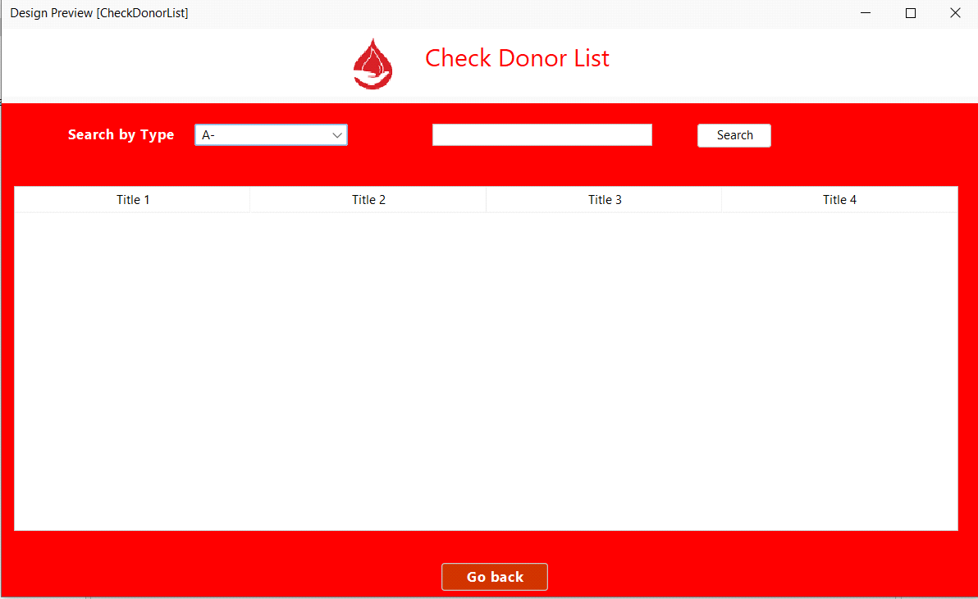

### **Use Case UC2: Donate Blood**

|  |
| --- |
| **Scope**: Blood donation management system  **Level**: user goal  **Primary** **Actor**: Donor  **Stakeholders and Interests**:   * Blood banks: blood bank get the blood for storage which will be put to use later. * Receiver: Receiver receives the blood which is required by the receiver. * Donor: Donor gets to donated blood as he is willing to donate in   **Pre-condition:**  The seeker or blood bank can request donor to donate blood or the donor can also donate blood without request the pre condition is if the donor is legible for a blood donation i.e. after how long the donor is donating the blood the condition is that he can only donate blood after 4 months since he last donated. |

**Success Guarantee** (or Postconditions): Successful outcome of the use case will be that the donor will be able to donate blood

**Main Success Scenario (or Basic Flow):**

* Donor clicks on donate blood (if he is ready for the donation)
* Donor then give proper details
* Donor successfully donates blood

**Extensions (or Alternative Flows):**

* Donor cant donate blood because his last donation has not completed 4 months
* Donor is legible but is not willing to donate blood

**Special Requirements:**

* Text should be bold and clear
* UI should have elements on the appropriate places
* Text must be visible from 1 meter.
* Result should be displayed within 30 seconds 90% of the time.

**Technology and Data Variations List**:

Donor will be notified if he is needed for the blood or he can donated willingly on the system by sending a message.

**Frequency of occurrence:**

Possibility after every four months.

**Open Issues:**

* Can donor donate before his 4 months completion
* Is the donor eligible for the blood donation
* How will the donor donate blood
* How will seeker get blood
* How it will be known if the seeker is truly needy for the blood.

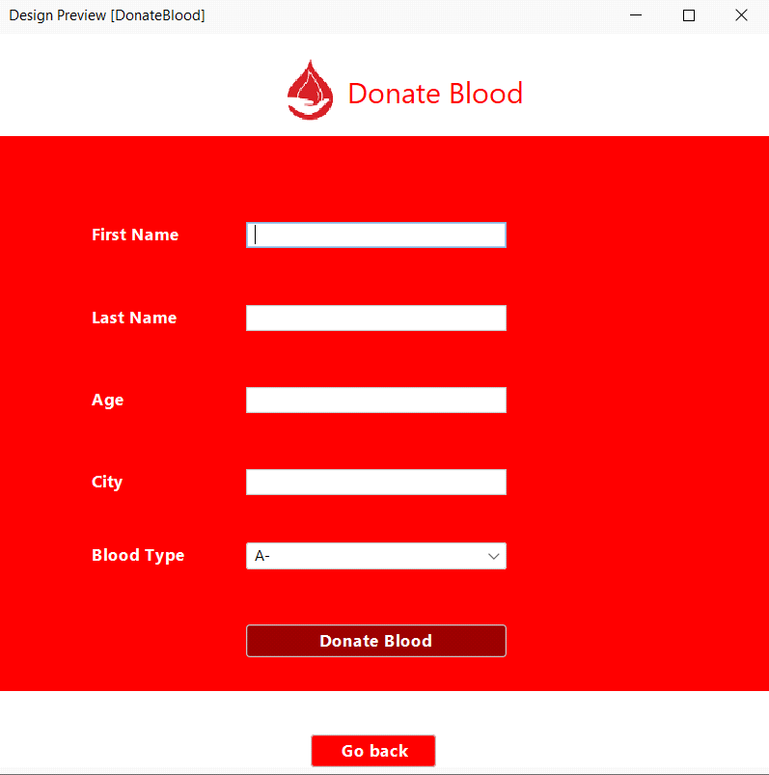**Screen Shots:**

End of My use case(SP21-BSE-026)

Fully Dressed Use Cases

Ahmed Imtiaz Bajwa (Fa20-Bse-169)

Use Case 1: Reward System

|  |  |
| --- | --- |
| **Use Case Section** | **Comment** |
| **Use Case Name** | Reward System |
| **Scope** | NextGen blood donation management system |
| **Level** | User goal |
| **Primary Actor** | Admin |
| **Stakeholders and Interest** | Admin wants Accurate delivery of reward to doner |
| **Preconditions** | Seeker has requested to give a reward to doner |
| **Success Guarantee** | Seeker reward request has accepted, reward has been collected and deliver or hand over to the correct doner |
| **Main Success Scenario** | 1.seeker arrives at the reward center,  2.Admin adds the reward data.  3.It is saved by the system.  4 System presents a receipt.  5.seeker leaves with the receipt.  6.Reward is delivered to the doner. |
| **Extensions** | At any time, admin can override the operation |
| **Special Requirements** | Touch screen UI on a large flat panel monitor. Text must be visible from 1 meter. |
| **Technology and data Variations List** | Admin can enter the system using an OTP |
| **Frequency of Occurrence** | Could be nearly continuous |
| **Miscellaneous** | Any problem |

When the seeker wants to give a reward to the donor. A form will be shown to him in which he will write all the details of the event when was blood given what was the case and who was the doner and what will be the reward .it will be approve by the admin and the reward will be deliver to the doner.

Use Case 2: Check Emergency

|  |  |
| --- | --- |
| **Use Case Section** | **Comment** |
| **Use Case Name** | Check Emergency |
| **Scope** | NextGen blood donation management system |
| **Level** | User goal |
| **Primary Actor** | Admin |
| **Stakeholders and Interest** | Admin wants Accurate and fast delivery of blood to seeker |
| **Preconditions** | Seeker has requested blood of emergency type |
| **Success Guarantee** | Seeker blood request has accepted, blood has been collected and deliver or hand over to the correct seeker as soon as possible |
| **Main Success Scenario** | 1.seeker arrives at the reward center, or website.  2.seeker adds the blood details.  3.System checks the availability of blood.  4.if it’s available the system ask the way of delivery and if it is not it will notify the admin.  5.seeker enter the details for delivery.  6.record has been added to the system. |
| **Extensions** | At any time, admin can override the operation |
| **Special Requirements** | Touch screen UI on a large flat panel monitor. Text must be visible from 1 meter. |
| **Technology and data Variations List** | Admin can enter the system using an OTP |
| **Frequency of Occurrence** | One a while |
| **Miscellaneous** | Any problem |

.

|  |
| --- |
|  |

In case of emergency the blood will be delivered to the seeker as soon as possible. The seeker will request blood in emergency type it will be top priority of the admin to deal with this request first .and try to deliver blood as soon as possible

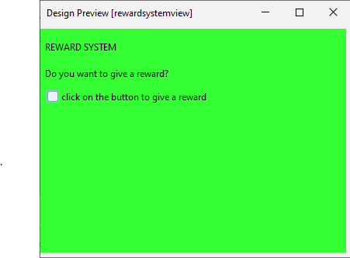

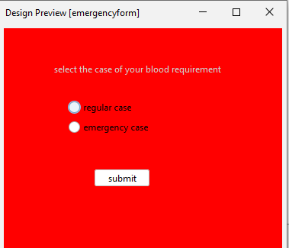

|  |
| --- |
|  |

**Fully Dressed Use Cases**

Muhammad Ali Raza (FA20-BSE-048)

Use Case 1: Sign Up

**Scope:** Blood Donation Management System

**Level:** The User goal is to Registration into the system.

**Primary Actors:** Admin, User

**Stake holders and Interests:**

* **Admin:** checks the information required by user and decides to give approval or not to give approval.
* **User:** can register to either donate blood or becomes receiver in case.

**Precondition:**

* The user wants to register and is not registered already.
* Email or Mobile Number is Must.

**Success Guarantee:**

The user will use the system to donate or receive blood and be able to use all features.

**Main Success Scenario (or Basic Flow):**

* The user will be able to use the system services.
* The user can search for the donors or receivers if he wants to donate the blood.
* The user can easily access the reward and other perks provided by the system.

**Extensions (or Alternative Flows):**

* The admin can’t approve the registration because of incorrect information provided.
* After the registration user deleted their profile because of reasons i.e. they don’t find it interesting or facing difficulties in using because of complex interface.

**Special Requirements:**

* The user has to provide both email and phone number to register.
* The password should be minimum of 8 words with the mixture of letters, digits and other special characters.

**Technology and Data Variations:**

The user will be informed by some kind of email confirmation after the registration confirmed

**Frequency of occurrence:**

* Every time user wants to use the system and is not registered already.
* They will occur only onetime as the client tries to get himself register.

**Miscellaneous:**

* Is user being able to enter the system interface without login or signup?
* Is user being able to use some features without by login or signup?

Use Case 2: Search Donor

|  |  |
| --- | --- |
| **Use Cases** | **Comments** |
| Use Case | Search Donor |
| Scope | Blood Donation Management System |
| Level | Function |
| Primary Actors | Admin, Receiver |
| Stake holders and interests | Admin: Allow the receiver to search for the requested blood donor and create a communication link between the donor and receiver.  Receiver: Search for the required blood donor and after the match make a contact with them to receive blood. |
| Precondition | The receiver is already registered on the system and the required blood group is available to search for. The donor register must be able to donate blood and dos not have any disease or issues which can’t let them to donate the blood. |
| Success Guarantee | The receiver will receive the blood and donor will be rewarded with the certificate. |
| Main Success Scenario | * The receiver will contact the donor. * The receiver fulfill the requirements of the donor like transport etc. if required. * Then donor give blood and then they receive certificate. |
| Extensions | * The blood group does not available at the moment. * The receiver can’t be able to fulfill the donor’s requirements and then they need to find other donor. |
| Special Requirements | * The donor must have to be in the same city as receiver. * The donor must not have donated blood in past four months to donate. |
| Technology and Data variation | The donor will be issued a virtual certificate the moment they donate blood to encourage them to donate regularly. |
| Possibility of occurrences | Every time receiver needs blood they search for the donor to receive blood. |
| Miscellaneous | * Is in the case of emergency the donor must have to register first to search for the donor or to receive blood from donor. * Is the donor within the family has to register in the system to donate blood. |
|  |  |

Screenshot

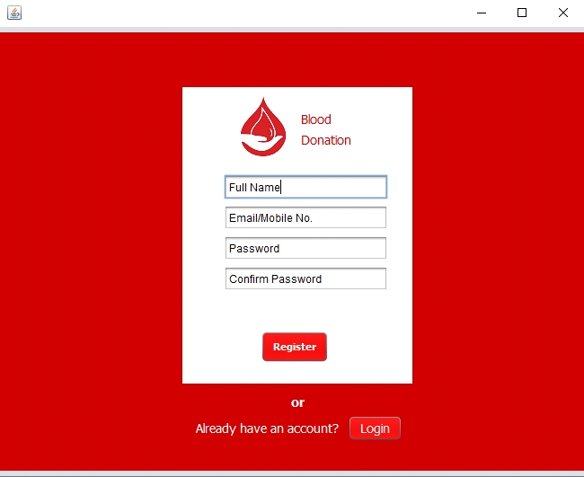

**Fully Dressed use case:**

* **Manage System: (SP21-BSE-030)**

|  |  |
| --- | --- |
| **Use Case Section** | **Comment** |
| Use Case Name | Manage system |
| Scope | Blood donation management system |
| Level | Subfunction |
| Primary Actor | Admin |
| Stake holders and interests | Admin: |
| Pre conditions | If there is any changes in the system requires or controlling data of Donor, Seeker and Blood bank the it will the responsibility of the system manager (Admin)to check for these things |
| Success guarantee | The system will work well and efficiently |
| Main Success Scenario | * The donor and seeker will register their selves under the control of Admin * Admin will store and update the Donor, seeker and Blood bank data. * Donor can now add his name as a donation of blood to blood bank or seeker * Seeker and blood bank can also now take and Blood bank will keep the data of donor and seeker * Admin will give the reward given by seeker to Donor as a Thank or by some Special gift |
| Extensions | * Donor registered him/his self but not accessing the site * Seeker also registered but no accessing the site * System is not working properly |
| Special Requirements | * Admin should have access to add or remove a donor or a seeker data. |
| Technology and Data Variations List | Admin can search the donor list on the website while logged in using his password and username given to him. |
| Frequency of Occurrences | continuously |
| Miscellaneous |  |

* **Check stock (SP21-BSE-030)**

|  |  |
| --- | --- |
| **Use Case Section** | **Comment** |
| Use Case Name | Check stock |
| Scope | Blood donation management system |
| Level | User -goal |
| Primary Actor | Blood Bank |
| Stake holders and interests | * Blood banks: blood bank get the blood for storage which will be stored in stock to use later. |
| Pre conditions | . Blood bank will check for the stock if any shortage then completes their shortageness by getting the blood from the donor or purchase from other organization for storage which will be stored in stock to use later. |
| Success guarantee | Successful outcome of the use case will be that the Blood bank will service blood to seeker if there any in the stock |
| Main Success Scenario | * Blood bank check their stock * If the stock is in Shortage of any type of blood group * Blood bank search for legible donor or to purchase from other blood bank * Blood bank finds a legible donor and asks donor for blood * After taking blood from them thy will cover their shortage of stock |
| Extensions | * Blood not found of the type they are searching for * Other banks also gave shortage of that type blood group * Donor is legible but is not willing to donate blood |
| Special Requirements | * the stock should be checked regularly |
| Technology and Data Variations List | System should give an alert alarm if any shortage of blood of a special blood group type |
| Frequency of Occurrences | Checking stock regularly after any blood donation to a seeker |
| Miscellaneous | * Shortage of Blood |

**Screenshots:**

Use case 1: Manage System (SP21-BSE-030)

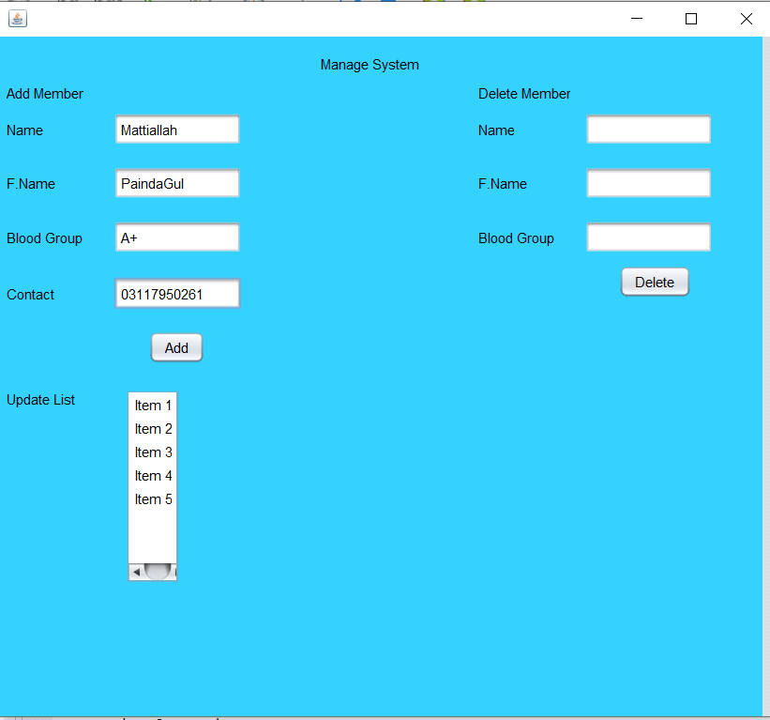

Use case 2: Check Stock (SP21-BSE-030)

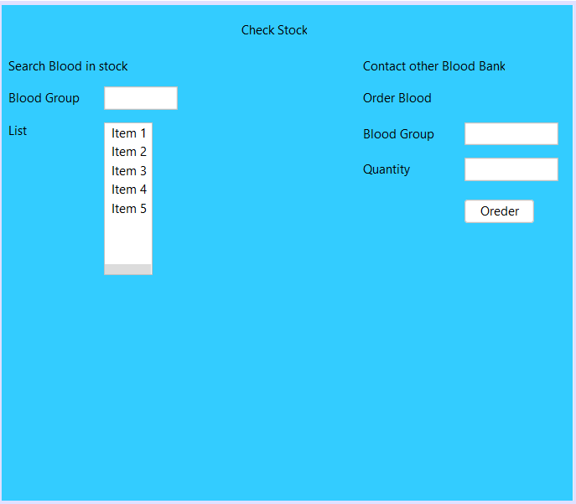

**Fully Dressed use case:(sp21-bse-005)**

**Muzamil shirzad**

* **Request blood**
* **Conduct test**

**1.Request blood donation**

|  |  |
| --- | --- |
| **Use Case Section** | **Comment** |
| Use Case Name | Request blood |
| Scope | Blood donation management system |
| Level | User goal |
| Primary Actor | Donor |
| Stake holders and interests | * Donor: donor will get to donate blood if he is willing and eligible * Receiver: receiver will get the blood which is needed * Admin: wants to run things between donor and seeker so admin will make sure that donor get to donate blood and seeker receives the blood |
| Pre conditions | * The Donor should have stable internet connection. * The Donor should register himself/herself by providing his/her credential. * The Donor should have valid email and password. * The donor will have access to request blood donation feature. |
| Success guarantee | * The Donor registers himself or herself to the application. * The donor signs in through valid username and password. * The admin verifies the email and password. * The donor request for the donation. * The admin approves his request and then he can donate his/her blood. |
| Main Success Scenario | * The donor request for the donation of the blood. * The blood bank approves the his/her request. * He/she successfully donate his or her blood. |
| Extensions | * Blood bank check for blood in the storage and the blood is available * Blood bank search for a donor and does not find an eligible donor * Donor is found but his 4 months of last donation are not completed * Donor is found but he is not willing to donate blood |
| Special Requirements | * Donor can donate blood after every 4 months * Free blood must be given to the needy and poor person * Donor and the seeker must be in range |
| Technology and Data Variations List | * Text should be bold and clear * UI should have elements on the appropriate places * Text must be visible from 1 meter. * Result should be displayed within 30 seconds 90% of the time. |
| Frequency of Occurrences | Could be nearly continuous. |
| Miscellaneous | * Is the donor eligible * Is the donor willing to donate blood * If the donor is located, will he be in range of the seeker * How the seeker will get the blood |

**2:** **Conduct test**

|  |  |
| --- | --- |
| **Use Case Section** | **Comment** |
| Use Case Name | Conduct test |
| Scope | Blood donation management system |
| Level | User -goal |
| Primary Actor | Donor |
| Stake holders and interests | * Blood banks: blood bank get the blood for storage which will be put to use later. * Receiver: Receiver receives the blood which is required by the receiver. * Donor: Donor gets to donated blood as he is willing to donate in |
| Pre conditions | * The Donor should have stable internet connection. * The Donor should register himself/herself by providing his/her credential. * The Donor should have valid email and password. * The donor will have access to request blood donation feature. * The donor will be eligible to donate the blood. |
| Success guarantee | Conduct tests of donation successfully |
| Main Success Scenario | * Blood bank check their stock * Blood bank search for legible donor * Blood bank finds a legible donor and asks donor for blood * Donor willingly donated blood |
| Extensions | * Donor cant donate blood because his last donation has not completed 4 months * Donor is legible but is not willing to donate blood |
| Special Requirements | * Conduct test after every 4 months for checking blood deseas |
| Technology and Data Variations List | Donor will be notified if he is needed for the blood or he can donated willingly on the system by sending a message. |
| Frequency of Occurrences | Possibility after every 4 months |
| Miscellaneous | * Can donor donate before his 4 months completion * Is the donor eligible for the blood donation * How will the donor donate blood * How will the seeker get blood * How it will be known if the seeker is truly needy for the blood. |

**Drag and drop Screenshots:**

**1:Request blood**

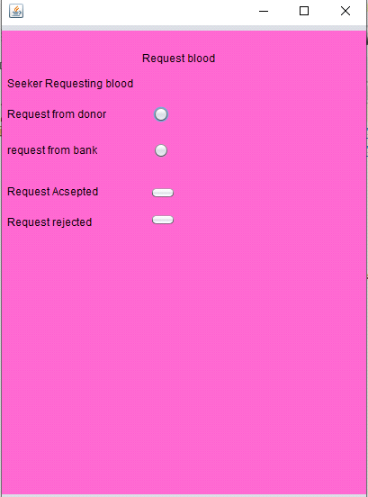

2:conduct test:

**Fully Dressed Use Cases**

Tayyab Rafique (SP21-BSE-024) Use Case1:Login

|  |  |
| --- | --- |
| Main Success Scenario | * This use case starts when an actor wishes to log into the blood donation management System. The system requests that the actor enter his/her name and password. The actor enters his/her name and password. The system validates the entered name and password and logs the actor into the system. * User can view all operations in Bloodbank |
| Extensions | * If password is wrong or any spelling mistake or gap between in the fonts are larger or any other grammaticall mistake than login become invalid than after correcting or reset the password we can log in the system |
| Special Requirements | * Admin should have access to login and reset password and add or   remove a donor or a seeker data. |
| Technology and Data Variations List | Admin can search the donor list on the website while logged in using his password  and username given to him. |
| Frequency of Occurrences | Could be nearly continuous. |
| Miscellaneous |  |
|  |  |
|  |  |

This use case starts when an actor wishes to log into the Course Registration System. The system requests that the actor enter his/her name and password. The actor enters his/her name and password. The system validates the entered name and password and logs the actor into the system

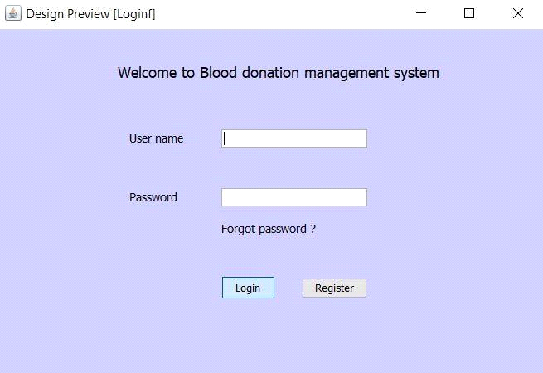

# **Chapter 3**

## **Domain model**

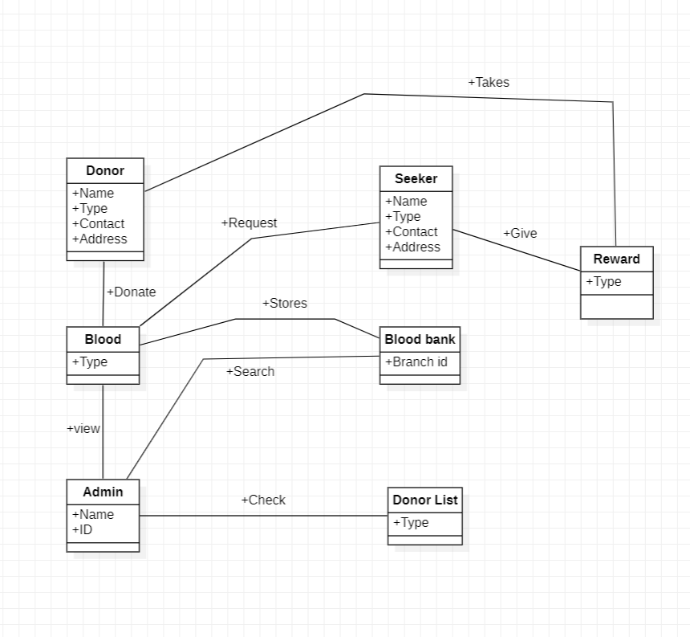

# **Chapter 4**

## **SSD**

### **Waleed khan (SP21-BSE-026)**

#### **SSD: Check donor list**

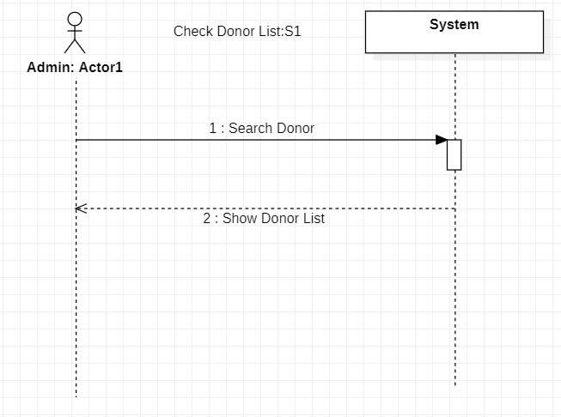

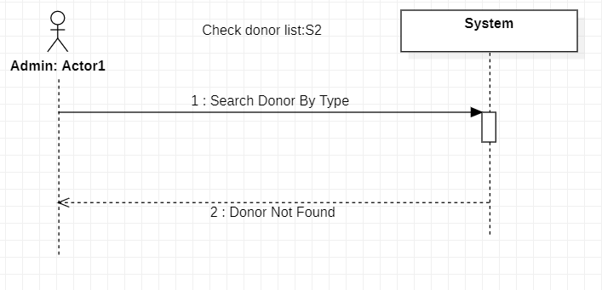

### **Waleed khan (SP21-BSE-026)**

#### **SSD: Donate Blood**

### **Forward Engineering**

### 

### **Backward Engineering**

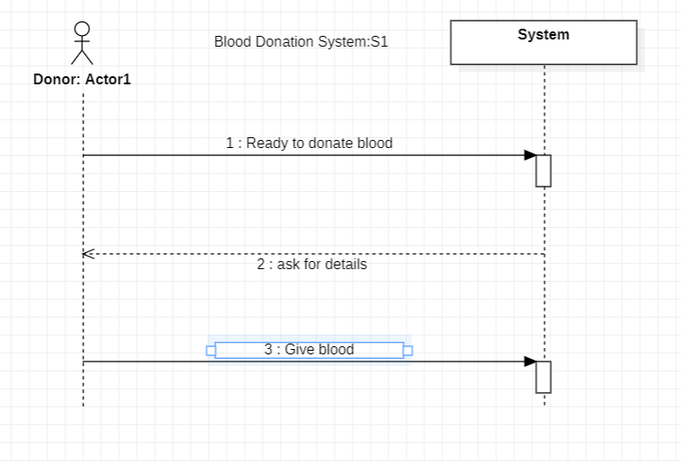

Muhammad Ali Raza (FA20-BSE-048)

*SSD: SignUp*

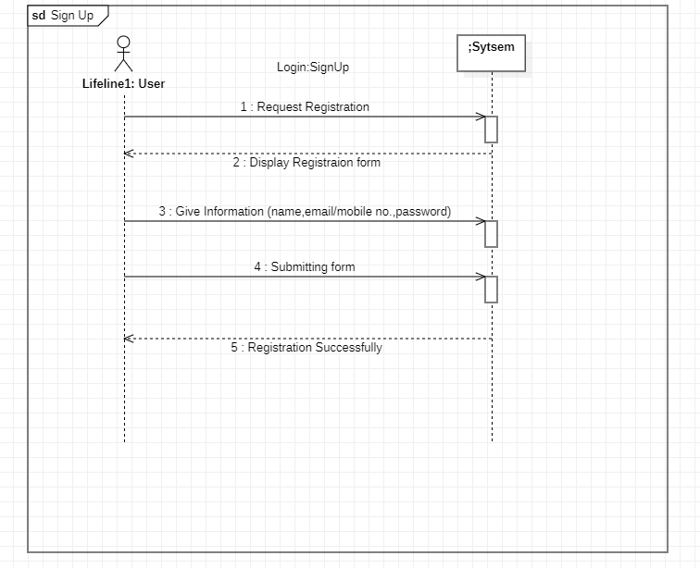

Mattiallah Safi (SP21-BSE-030)

*SSD: Manage System*

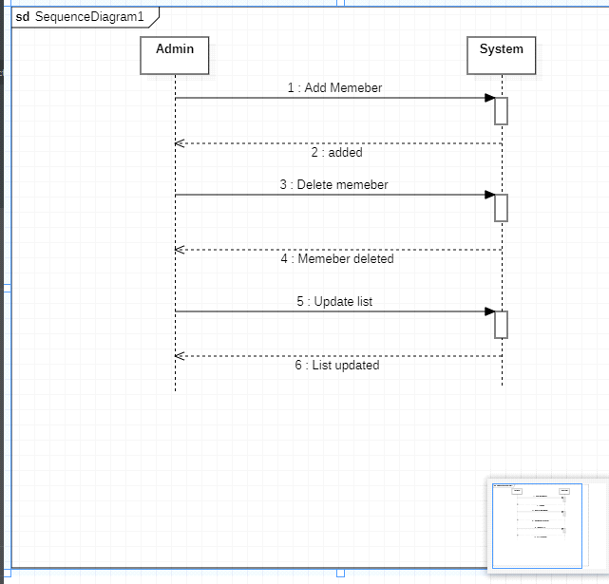

*SSD2(Check Stock)*

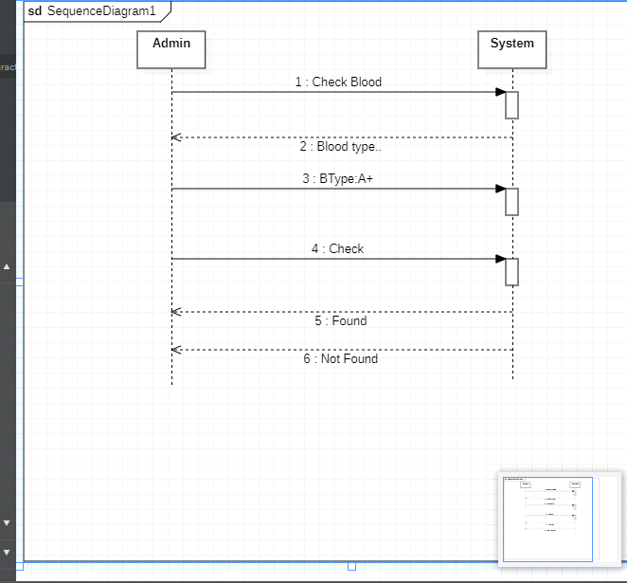

**Login (SSD)**

**Tayyab Rafique (Sp21-Bse-024)**

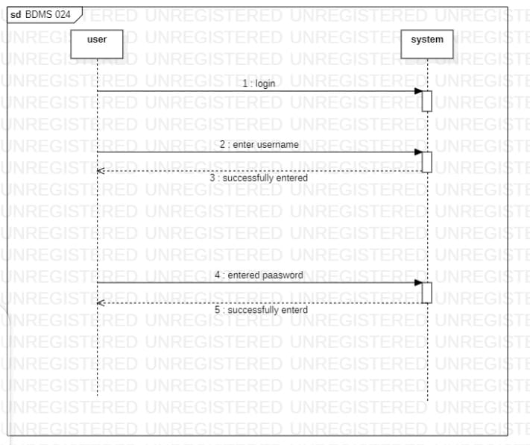

# **Chapter 5**

## **Operation Contracts**

### **Waleed Khan (SP21-BSE-026)**

|  |  |
| --- | --- |
| Contract C02: Search Donor | |
| Operation | Search Donor |
| Cross Reference: | Use Case: Check Donor: S1 |
| Preconditions: | Admin is logged in and searching for a particular donor or checking donors list |
| Postconditions: | Association is formed between controller and creator  An instance of controller is created  An instance of SQL is created  An instance of response is created  An instance of DAL is created  An instance of record adder is created  Association is formed between dal and sql connection  Association is formed between dal and common validator  Association is formed between dal and record adder |

|  |  |
| --- | --- |
| Contract C03: Ready to donate blood | |
| Operation | Give Blood |
| Cross Reference: | Use Case: Donate Blood: S1 |
| Preconditions: | Donor is logged in and is ready to donate blood |
| Postconditions: | Association is formed between controller and creator  An instance of controller is created  An instance of SQL is created  An instance of response is created  An instance of DAL is created  An instance of record adder is created  Association is formed between dal and sql connection  Association is formed between dal and common validator  Association is formed between dal and record adder |

Muhammad Ali Raza (FA20-BSE-048)

Operation Contracts

**Use case 1:** (Request for Registration)

|  |  |
| --- | --- |
| Operation Constraints | Sign Up |
| Operation | Request Registration() |
| Pre-Condition | The user is not registered Yet |
| Post Condition | Provide the information Regarding Name, Email/Mobile No, Password, Confirm Password |

**Use case 2:** (Give Information)

|  |  |
| --- | --- |
| Operation Constraints | Sign Up |
| Operation | Give Information() |
| Pre-Condition | Request to Register |
| Post Condition | Registered successfully |

Mattiallah Safi(Sp21-Bse-030)

|  |  |
| --- | --- |
| Contract C01: Add Member | |
| Operation | Add member (Type: String) |
| Cross Reference: | Use Case: Manage System: S1 |
| Preconditions: | Admin Must logged in To make change |
| Postconditions: | Admin will check for new members And if any exist he will add him i.e. Admin and Member list |

|  |  |
| --- | --- |
| Contract C03: Manage List | |
| Operation | Update List(Type :String) |
| Cross Reference: | Use Case :Manage System: S1 |
| Preconditions: | Donor must logged in |
| Postconditions: | Admin will Update the list and check for the Donors and Seekers and Update them regularly if any member is Added or Deleted |

**Login (Operation Contracts)**

**Tayyab Rafique (Sp21-Bse-024)**

|  |  |
| --- | --- |
| **Contract SP21-BSE-024: Login** | |
| **Operation:** | Login |
| **Cross References:** | Use Cases: Login |
| **Pre-conditions:** | * User selected the blood bank module as a blood bank instead of user and actor enter his or her name and password .The system validates the entered name and password and logs the actor into the system. |
| **Post-conditions:** | * After entering the password user can view blood bank operations and the system will work well and efficiently. |

# **Chapter 6**

## **Package Diagram**

### **Forward Engineering**

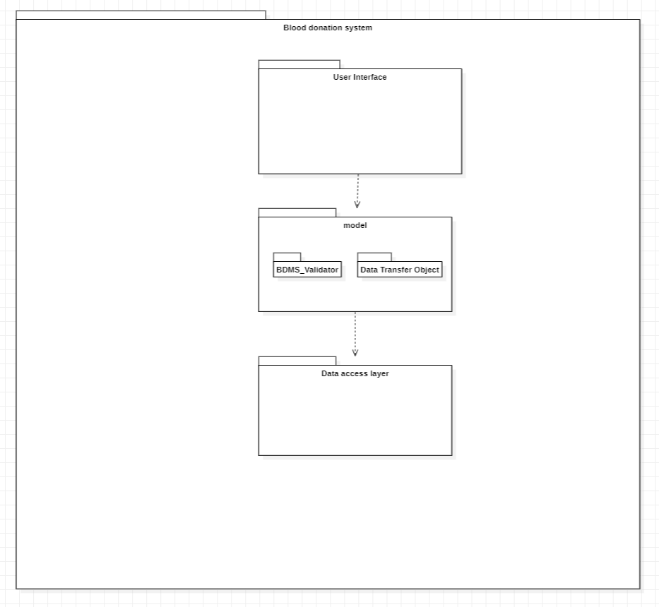

## **Reverse Engineering:**

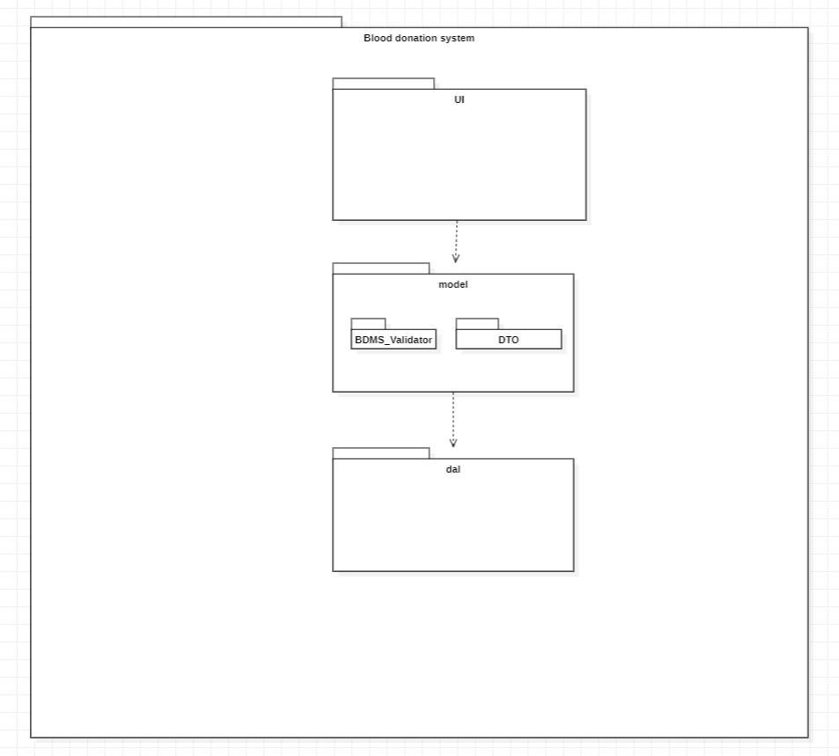

## **Chapter 7**

### **Interaction Diagram**

#### **Waleed Khan (SP21-BSE-026)**

##### **System event : check donors list**

###### **Forward Engineering**

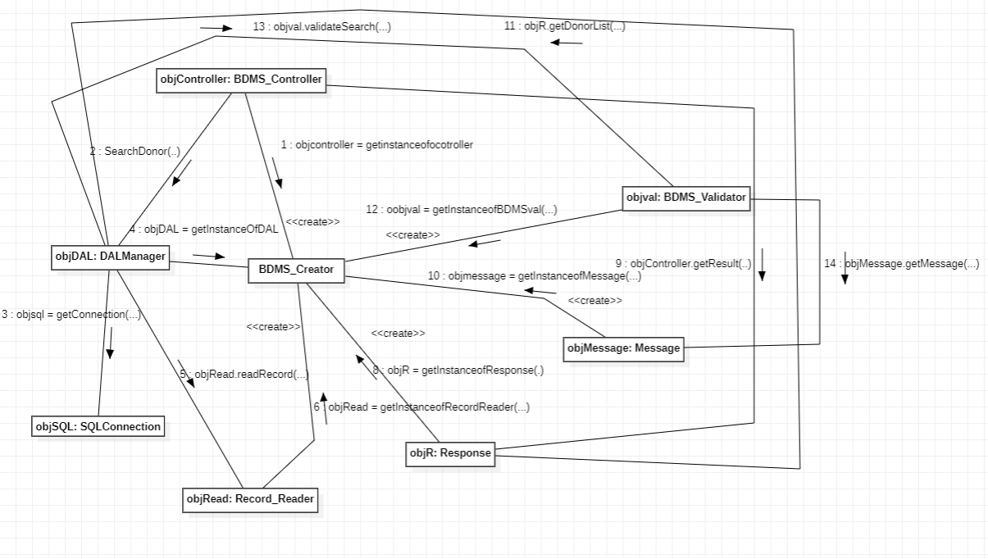**Reverse Engineering**

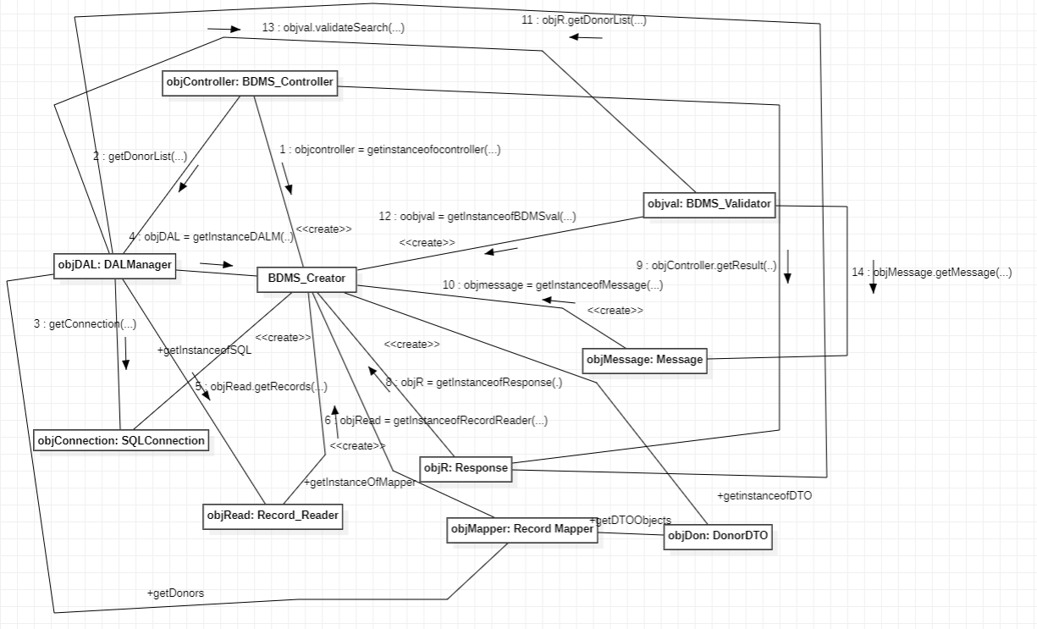

### **Communication diagram**

#### **Waleed Khan (SP21-BSE-026)**

##### **System event : Give Blood**

###### **FORWARD AND REVERESE ENGINEERING**

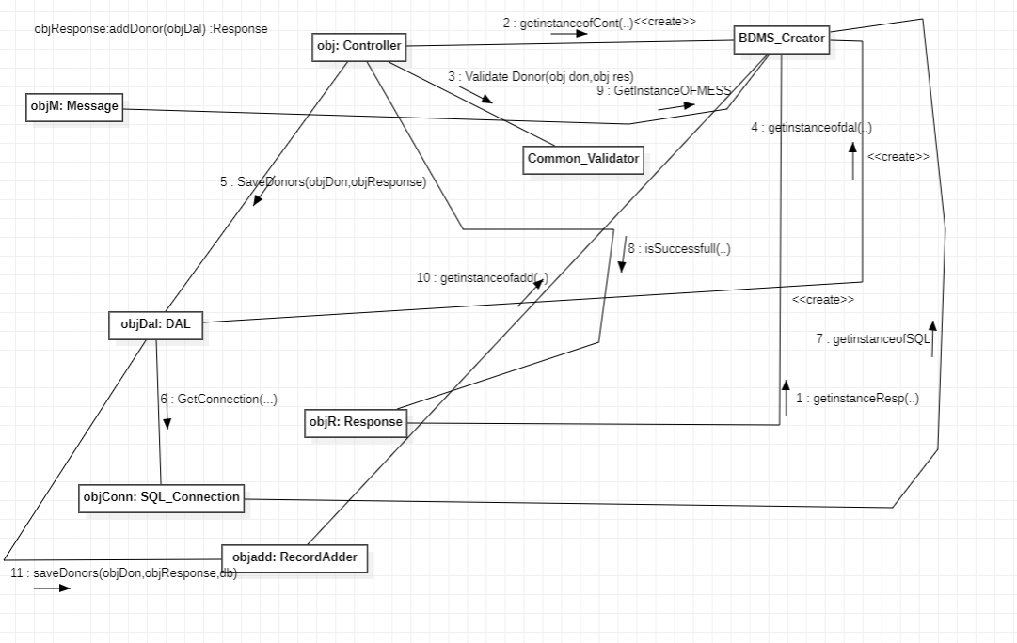

Found message is not included because in uml you cant add a found message.

# **Chapter 8**

## **Class Diagram**

### **Waleed Khan (SP21-BSE-026)**

#### **Forward Engineering (based on communication diagram)**

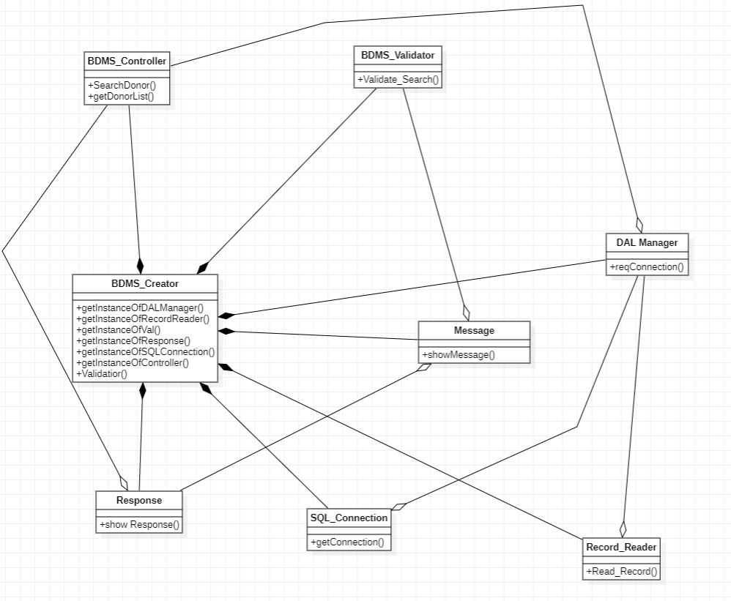**Reverse Engineering (based on communication diagram)**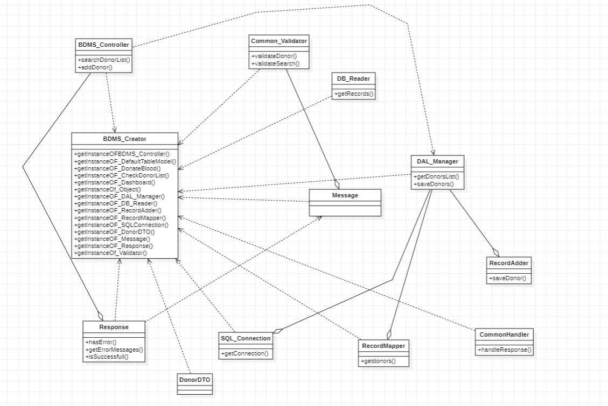

Zoom in to see the diagram more clear

# **Chapter 9**

## **Test Cases**

### **Waleed Khan (SP21-BSE-026)**

#### **Use case: Check donor list**

##### **ID: T001**

Title: Ensure that list is Displayed by First name

**Steps:**

1. Click on **check donor list** button on UI dashboard
2. Search the record by first name
3. Click on search

**Expected result:** list of donors with the searched first name is displayed

##### **ID: T002**

Title: Ensure that list is displayed by last name

**Steps:**

1. Click on **check donor list** button on UI dashboard
2. Search the record by last name
3. Click on search

**Expected result:** list of donors with the searched last name is displayed

##### **ID: T003**

Title: Ensure that list is displayed by Blood Type

**Steps:**

1. Click on **check donor list** button on UI dashboard
2. Search the record by Blood type
3. Click on search

**Expected result:** list of donors with the searched Blood type is displayed

##### **ID: T004**

Title: Ensure that list is displayed by Age

**Steps:**

1. Click on **check donor list** button on UI dashboard
2. Search the record by Age
3. Click on search

**Expected result:** list of donors with the searched Age is displayed

##### **ID: T005**

Title: Ensure that list is displayed by City

**Steps:**

1. Click on **check donor list** button on UI dashboard
2. Search the record by City
3. Click on search

**Expected result:** list of donors with the searched City is displayed

##### **ID: T006**

Title: Ensure that a tuple is displayed by Reg#

**Steps:**

1. Click on **check donor list** button on UI dashboard
2. Search the record by Reg#
3. Click on search

**Expected result:** list of a specific donor with the searched Reg# is displayed

### **Waleed Khan (SP21-BSE-026)**

#### **Use case: Donate Blood**

##### **ID: T007**

Title: Ensure that first name is not entered null

**Steps:**

1. Click on **Donate Blood** button on UI dashboard
2. Enter other details but first name remains null
3. Click on Donate.

**Expected result:** Error message is displayed due to the first name being null

##### **ID: T008**

Title: Ensure that last name is not entered null

**Steps:**

1. Click on **Donate Blood** button on UI dashboard
2. Enter other details but last name remains null
3. Click on Donate.

**Expected result:** Error message is displayed due to the last name being null

##### **ID: T009**

Title: Ensure that age is not entered null

**Steps:**

1. Click on **Donate Blood** button on UI dashboard
2. Enter other details but age remains null
3. Click on Donate.

**Expected result:** Error message is displayed due to age being null

##### **ID: T0010**

Title: Ensure that City is not entered null

**Steps:**

1. Click on **Donate Blood** button on UI dashboard
2. Enter other details but city remains null
3. Click on Donate.

**Expected result:** Error message is displayed due to the city being null

##### **ID: T0011**

Title: Ensure that age is not a non-numeric value

**Steps:**

1. Click on **Donote Blood** button on UI dashboard
2. Enter details along with age but age is given a non-numeric value
3. Click on Donate.

**Expected result:** Error message is displayed due to the age being a non-numeric value